**Readme file for Ex6-2 STK scenario**

This STK scenario executes a bi-elliptic Hohmann transfer. There is only one transfer type included that follows the book example.

Interceptor has the deltavs coded in and simply executes the mission profile.

The basic targeting sequence is as follows. Note that there is no iteration.

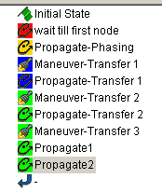

Because the process is very similar to Ex 6-1, I’ll just identify the parameters that are unique for this case. The maneuver must start at a node. Since the initial orbit is circular, it really doesn’t matter too much in this example.

Next, the phasing wait is 3000 seconds, again only driven by where the target is originally.

The maneuvers are simply inserted.

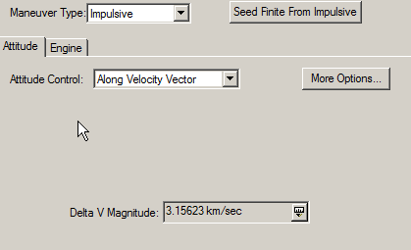

The propagation time must be entered manually, and this gets us o the larger diameter orbit. .

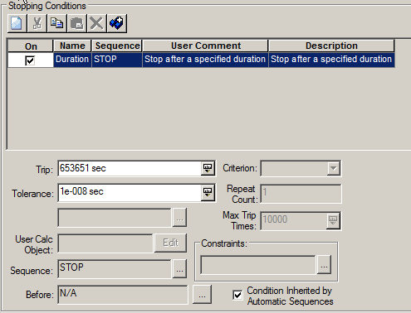

The second maneuver is as follows.

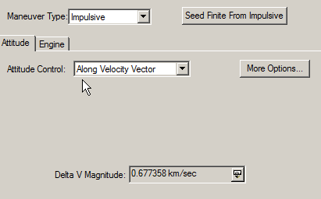

The next propagation is entered manually.

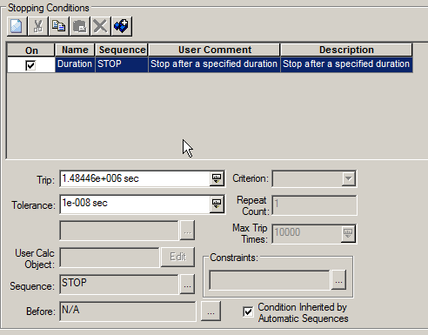

And the final maneuver to the final orbit is entered.

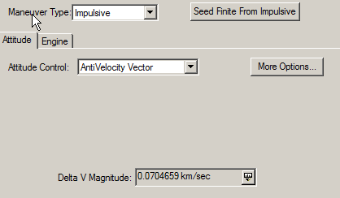

The remaining propagations simply let the satellite move along the final orbit.